**Assessment – Output Document**

**Author: Prathyusha Kochuru**

**Date: 06/13/2021**

**Tool used: Visual Studio Code, Eclipse**

**Service Used: My own Spring Boot API Service for KitchenStory**

**Project – KicthenStory.com**

1. **Home Screen:**

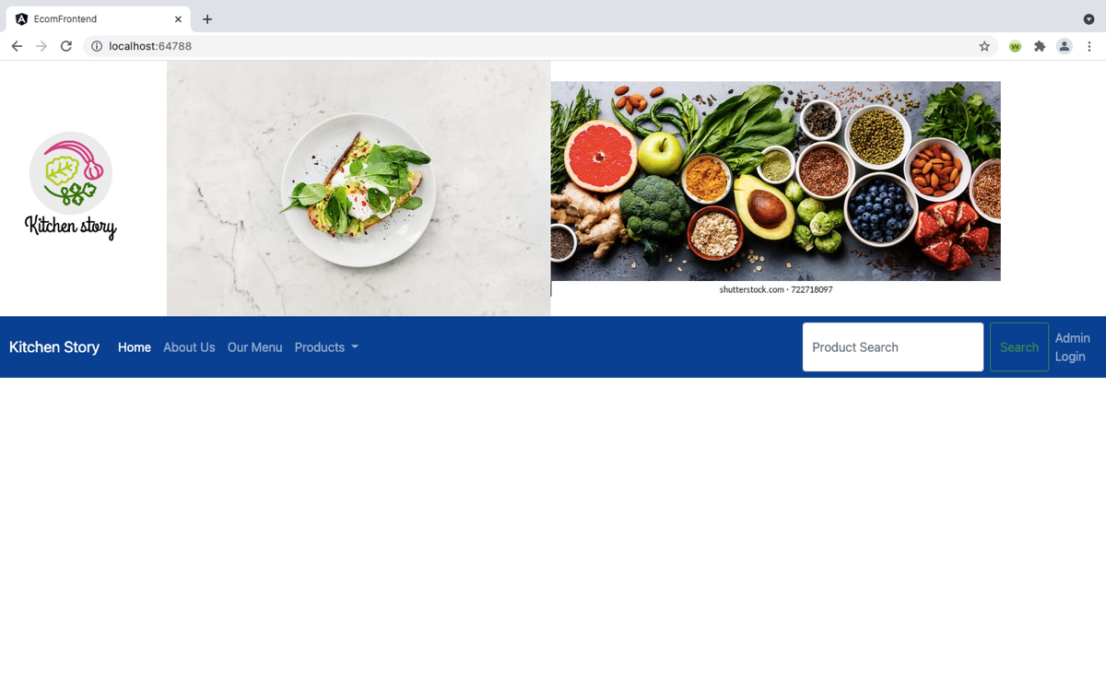

1. **About Us:**

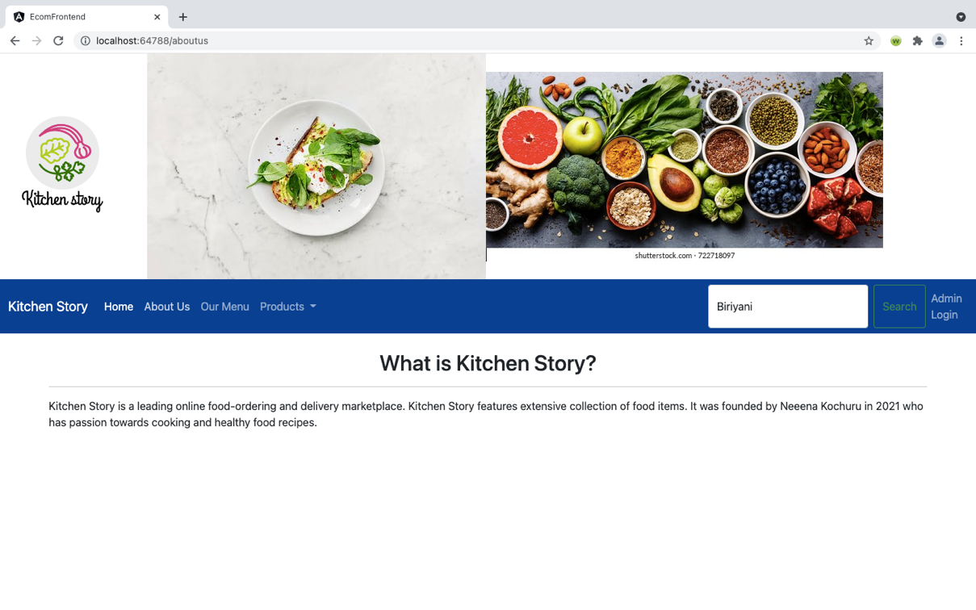

1. **Menu Page:**

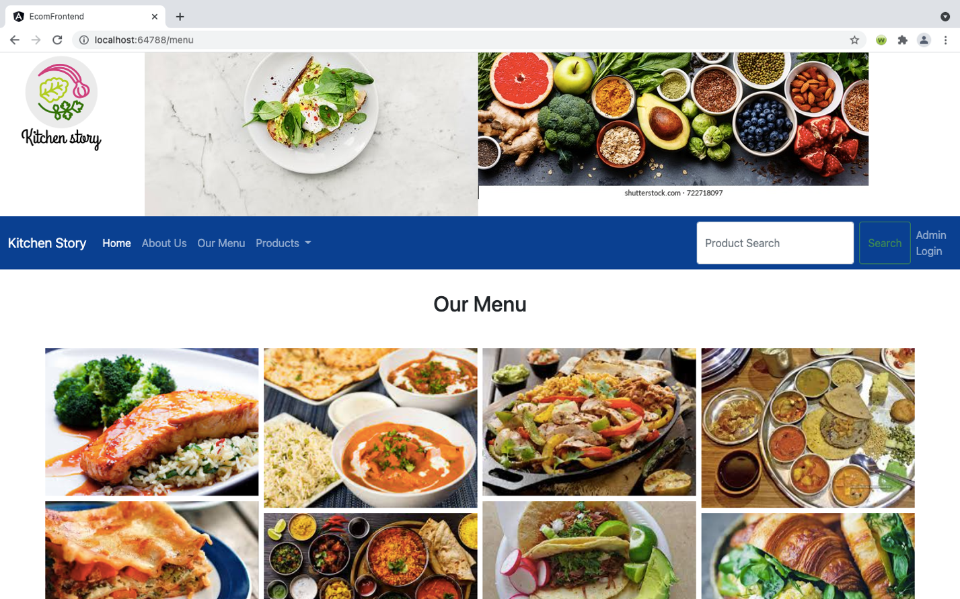

1. **Search Results Page:** Displays available food items based on search string from the home page.

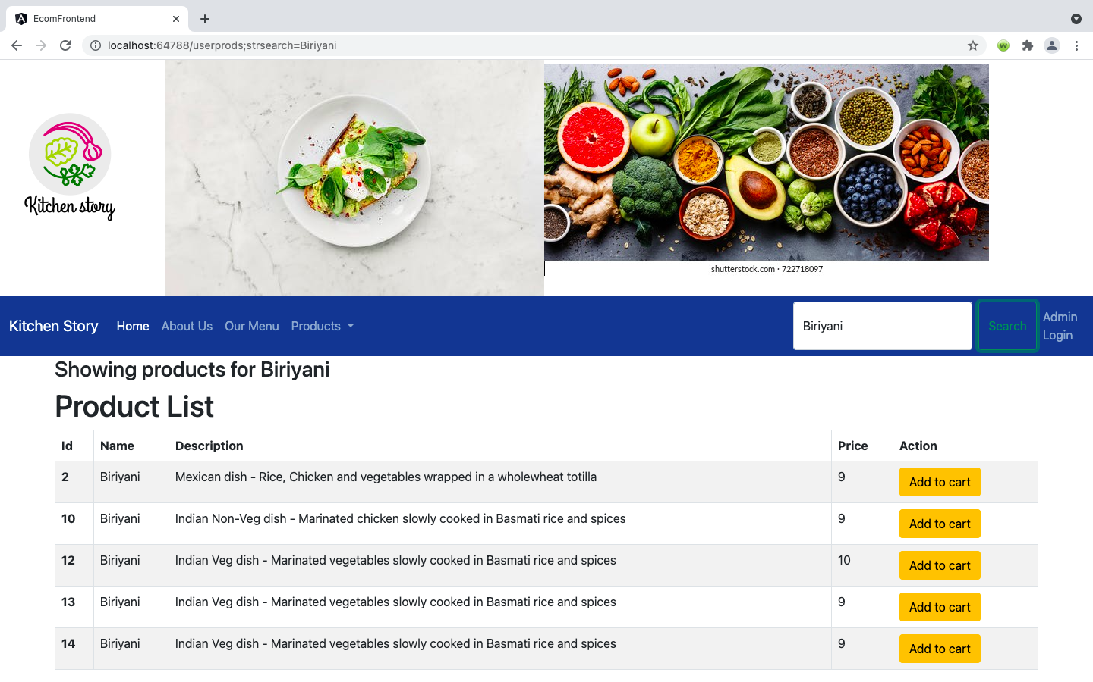

1. **Cart Page:** Shows the selected food item and allows user to check-out the cart.

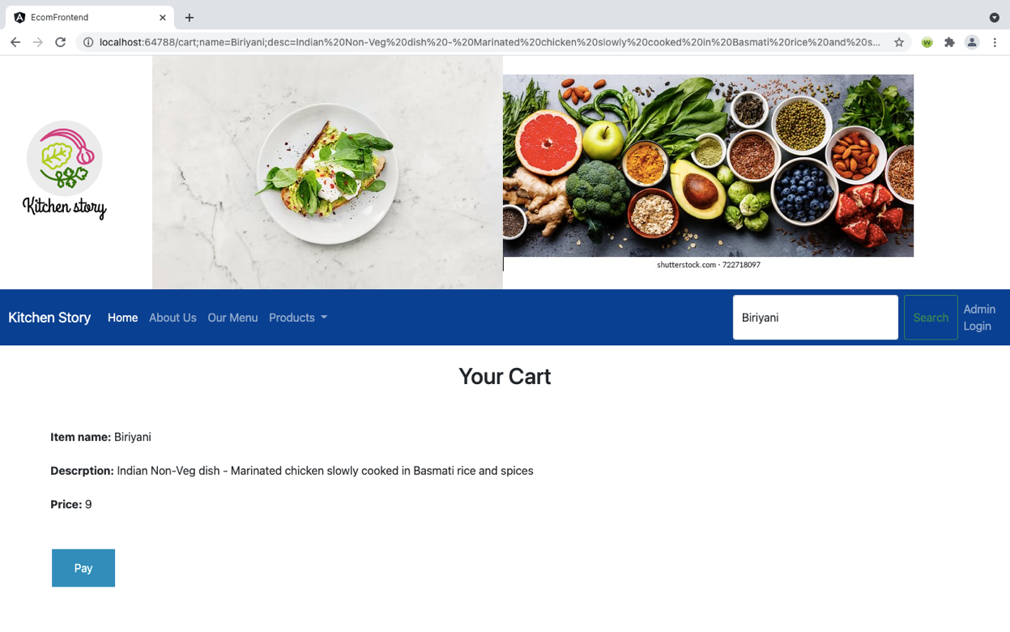

1. **Payment Checkout Page:** Allows user to make online payments using credit card checkout page by showing the cart and selected food item to pay.

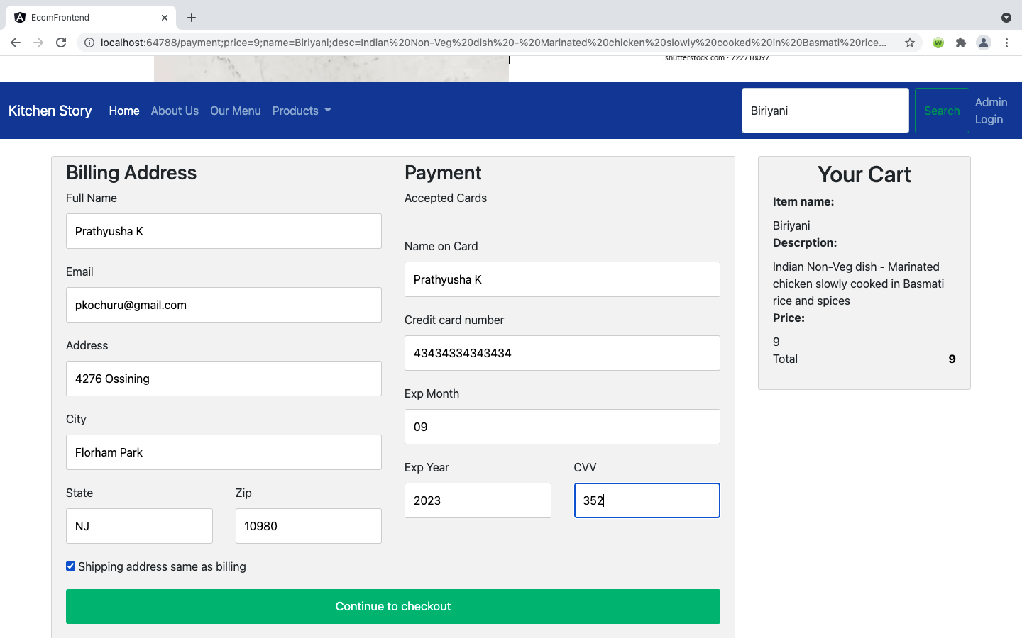

1. **Order Confirmation Page:** When user pays the order, it directs to this page by displaying confirmation message and the order number.

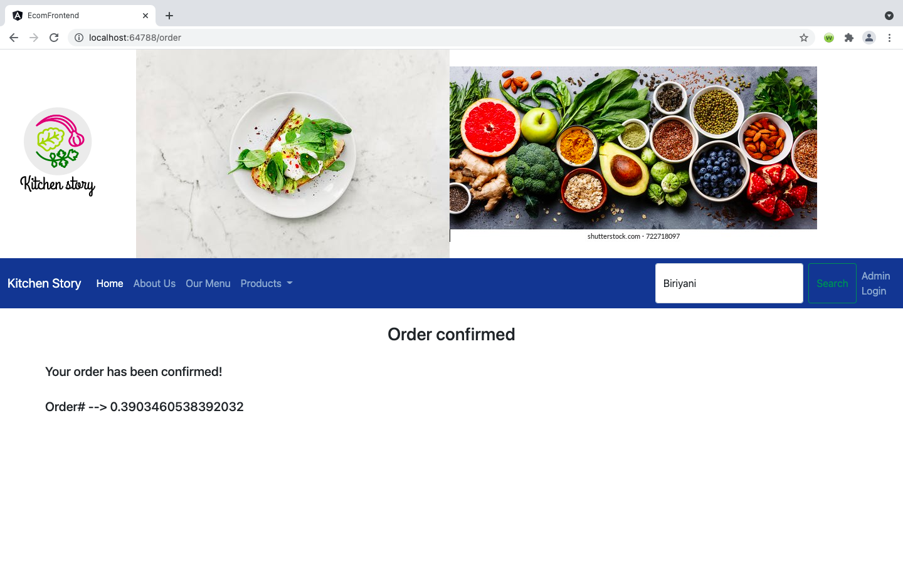

1. **Admin Login Page:** Allows ‘Admin’ to login and manage the food products list and ability to add new product.

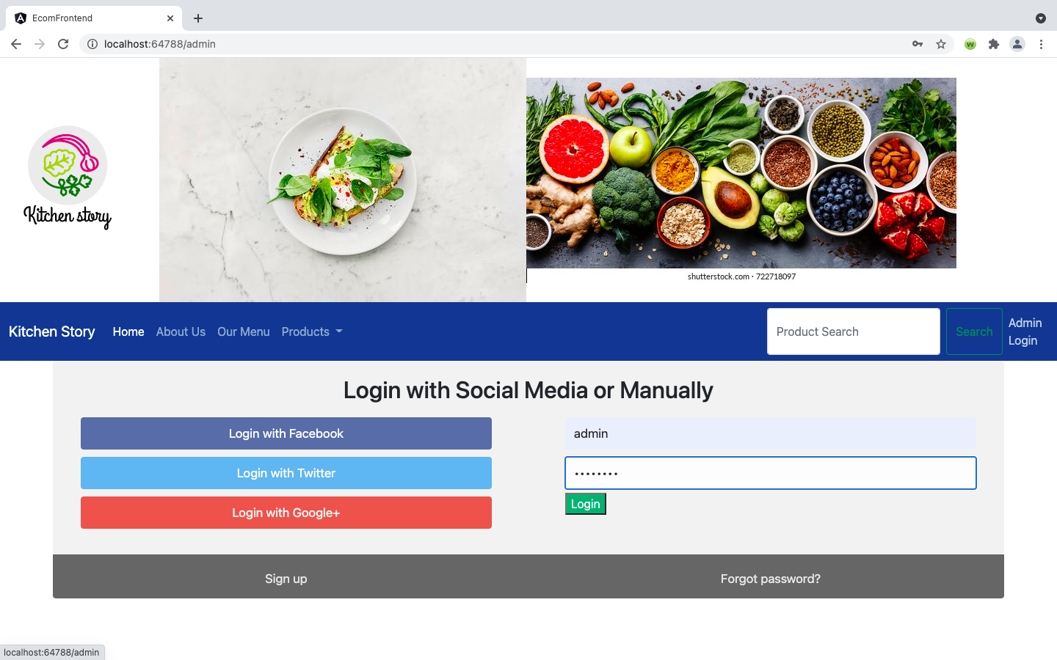

1. **Admin Page:** A welcome page for a logged in ‘Admin’ , displaying product list to manage the data and ability to log out. ‘Admin’ can edit/ delete/ create a new product.

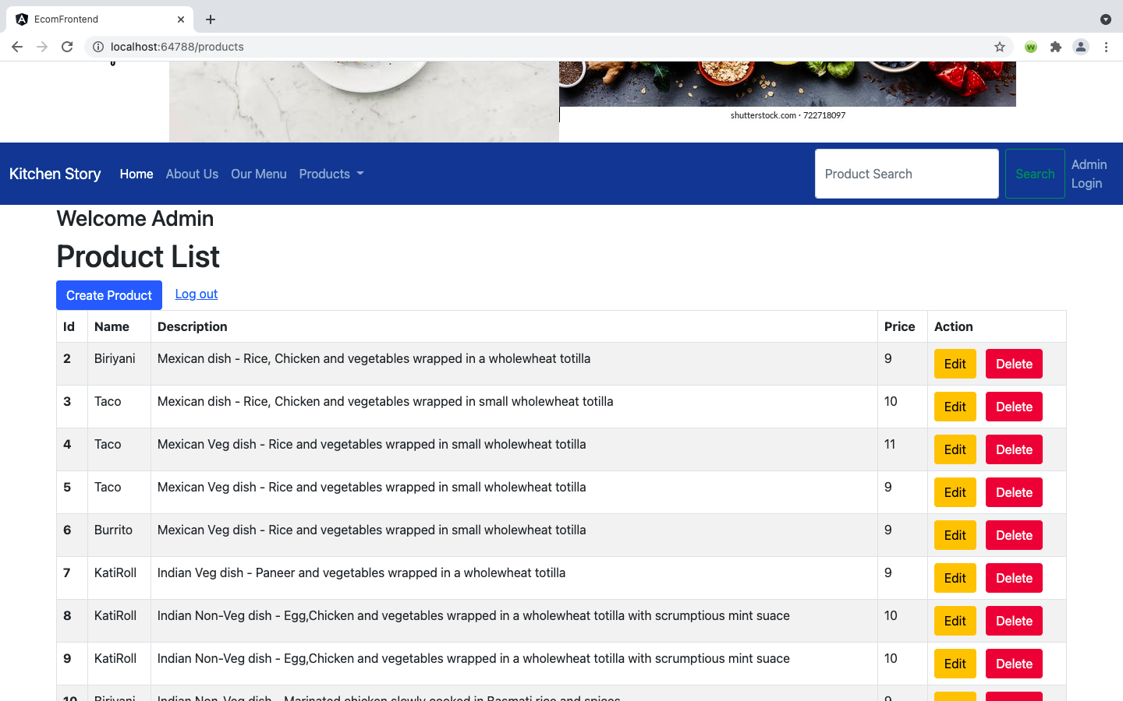

1. **Create a new Product page:** Where admin can add a new food product and save.

